AIR TRAFFIC AND NAVIGATION SERVICES SOC. LTD
REPUBLIC OF SOUTH AFRICA

REQUEST FOR PROPOSAL -ATNS/HO/RFP004/FY22.23/ATFM REPLACEMENT SYSTEM

ATFM Replacement Project

Volume 2 - Appendix

TECHNICAL SPECIFICATIONS APPENDIX

JUNE 2022

The information contained within this document is confidential to ATNS in all respects and it is hereby acknowledged that the information as provided shall only be used for the preparation of a response to this document. The information furnished will not be used for any other purpose than stated and that the information will not directly or indirectly, by agent, employee or representative, be disclosed either in whole or in part, to any other third party without the express written consent by the Company or its representative.

TABLE OF CONTENTS

1 Appendix-A: EXAMPLES OF Reports 4
1.1 Eurocontrol Report Example 4
1.2 TMI Monthly Statistics Report Example 5
1.3 Daily Departure Flight List Report Example 6
1.4 Daily Arrival Flight List Report Example 7
2 Appendix B: NMMS REPORTS 8
2.1 Device Availability Report Example 8
2.2 Device Port Details 9
2.3 Network Report Example 10
3 Appendix-C: Chart and graph reporting examples 11
3.1 Network Incoming and Outgoing Traffic Bar-Graph Report Example 11
3.2 Host Distribution and CPU & Memory Yearly Trend Reports Examples 12
4 Appendix-D: Dashboard examples 13
4.1 Device Summary Dashboard Example 13
4.2 VM Information Dashboard Example 14
4.3 Network Dashboard Example 15
4.4 Performance Dashboard Example 16
4.5 Host Service Status Dashboard Example 17
4.6 Complete Dashboard Example 18

TABLE OF FIGURES

Figure 1: Example of an Eurocontrol Report Layout and Display Example 4
Figure 2: TMI Monthly Statistics Report Example 5
Figure 3: Flight List Daily Departure Report Example for FAOR Airport (Full Date should be included as well) 6
Figure 4: Flight List Daily Arrival Report Example for FAOR Airport (Full Date should be included as well) 7
Figure 5: Device Availability Report Example 8
Figure 6: Port Details Report Example 9
Figure 7: Network Component Interconnection Layout and Multiple Distributed Devices Report Example 10
Figure 8: Network Incoming and Outgoing Traffic Bar-Graph Report Example 11
Figure 9: Host Distribution and CPU & Memory Yearly Trend Reports Examples 12
Figure 10: Device Summary Report Example 13
Figure 11: VM Information Report Example 14
Figure 12: Network Dashboard and Network Report Example 15
Figure 13: Performance Report Example 16
Figure 14: Host Service Status Report Example 17
Figure 15: Complete Dashboard Example 18

Appendix-A: EXAMPLES OF Reports

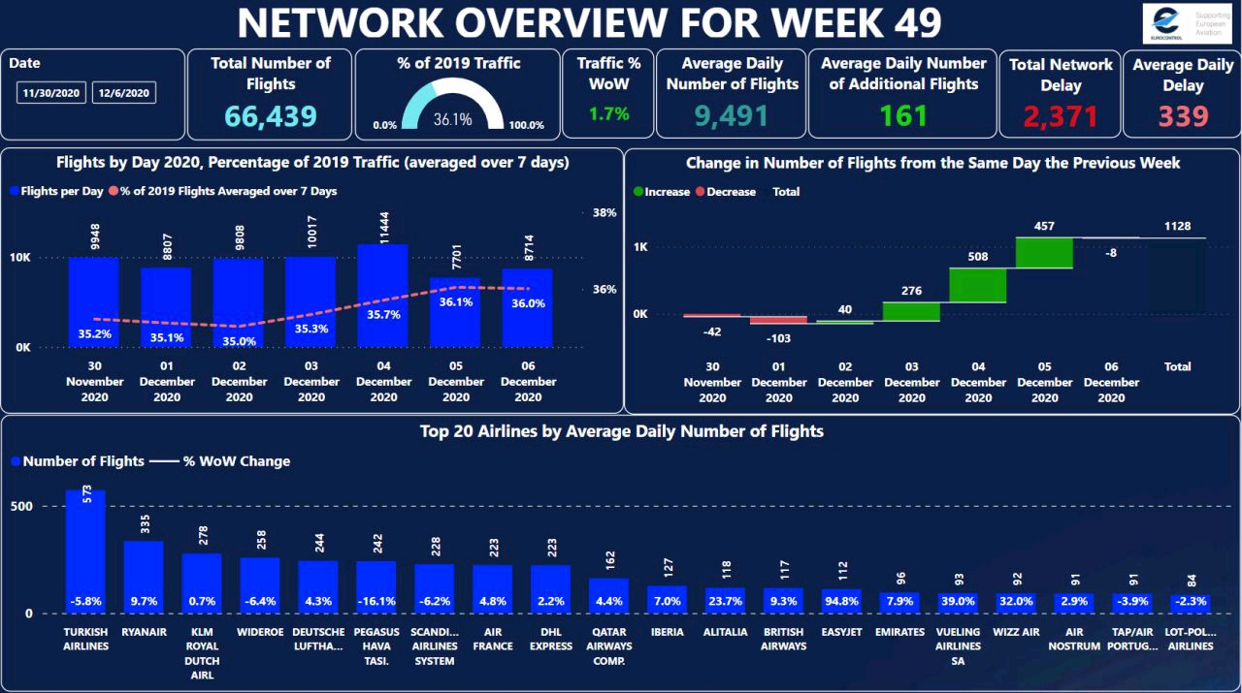
Eurocontrol Report Example

Figure 1: Example of an Eurocontrol Report Layout and Display Example

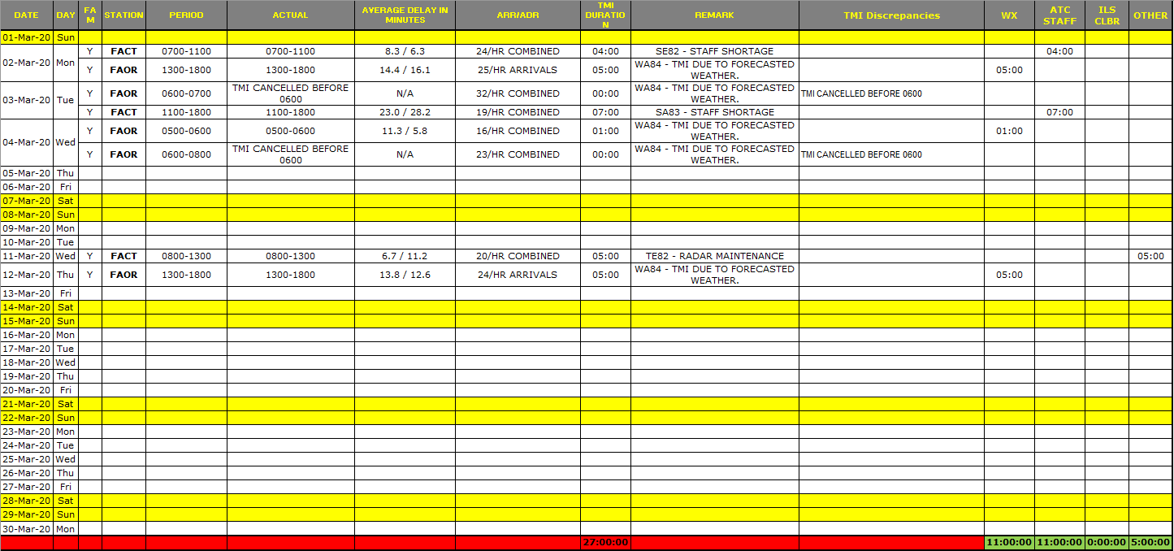
TMI Monthly Statistics Report Example
Figure 2: TMI Monthly Statistics Report Example

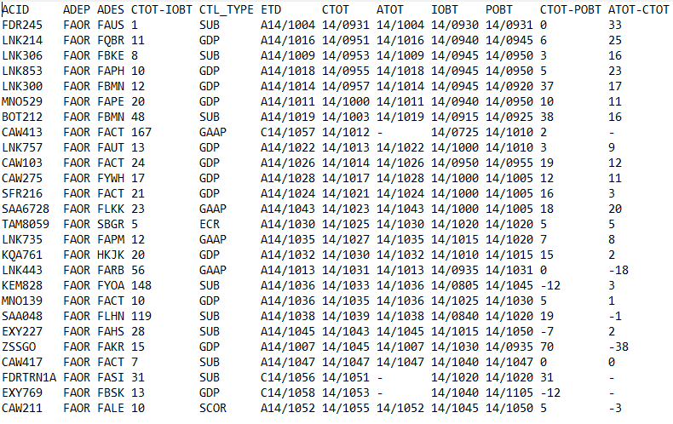
Daily Departure Flight List Report Example

Figure 3: Flight List Daily Departure Report Example for FAOR Airport (Full Date should be included as well)

Daily Arrival Flight List Report Example

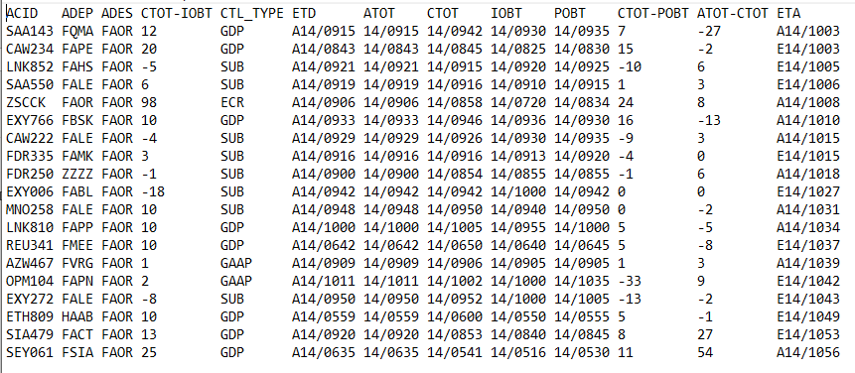
Figure 4: Flight List Daily Arrival Report Example for FAOR Airport (Full Date should be included as well)

Appendix B: NMMS REPORTS

Device Availability Report Example
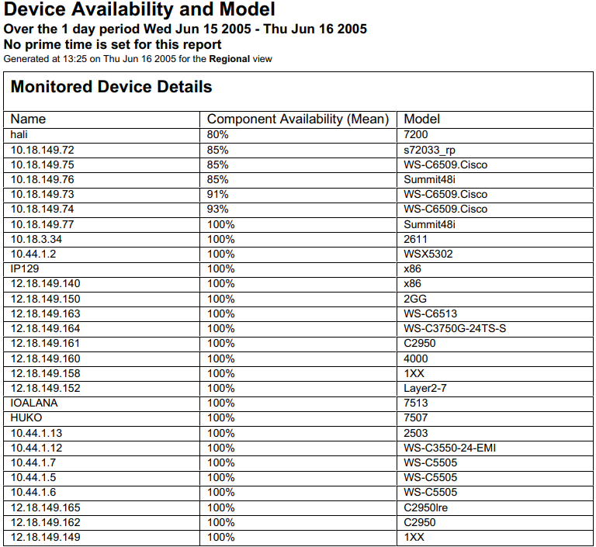

Figure 5: Device Availability Report Example

Device Port Details

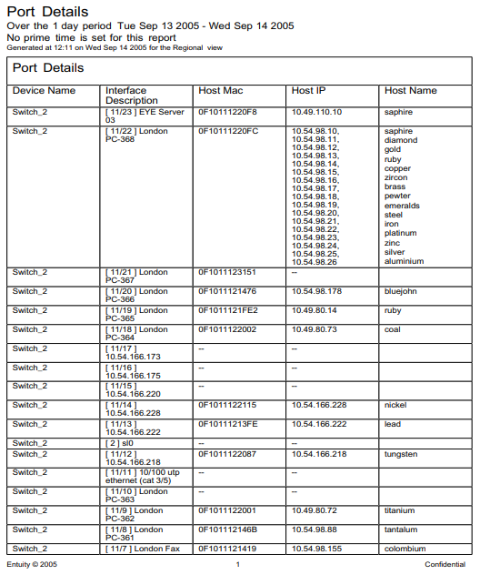
Figure 6: Port Details Report Example

Network Report Example
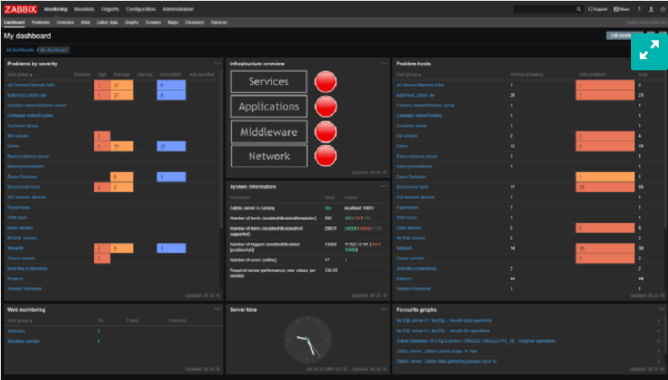
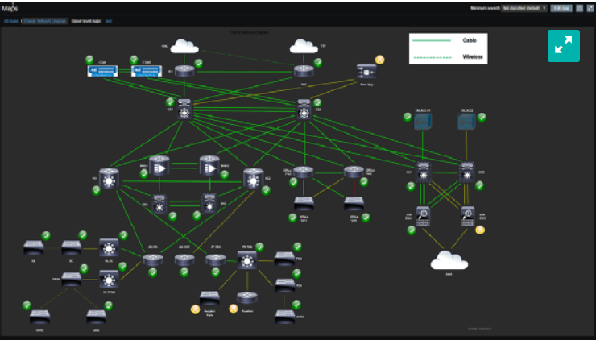

Figure 7: Network Component Interconnection Layout and Multiple Distributed Devices Report Example

Appendix-C: Chart and graph reporting examples

Network Incoming and Outgoing Traffic Bar-Graph Report Example
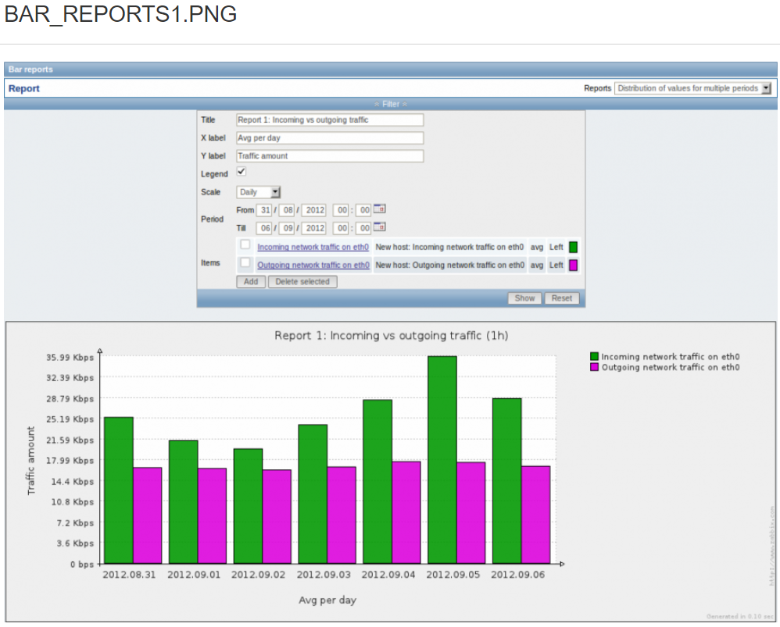
Figure 8: Network Incoming and Outgoing Traffic Bar-Graph Report Example

Host Distribution and CPU & Memory Yearly Trend Reports Examples
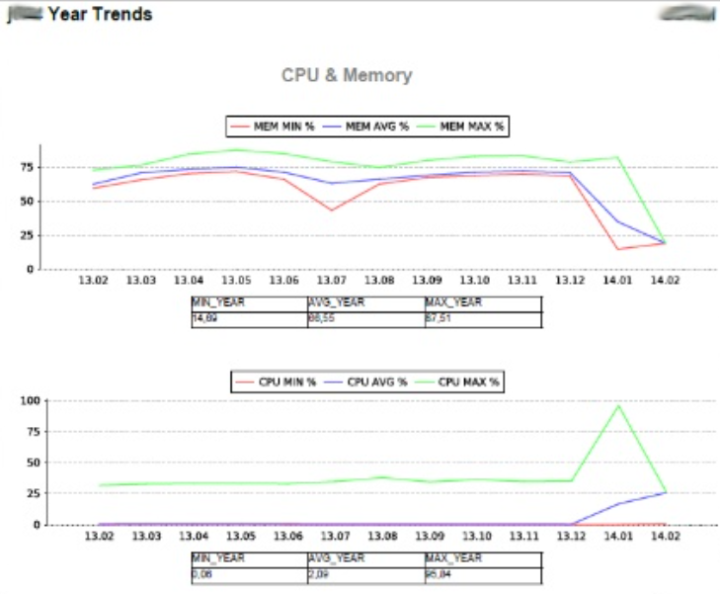
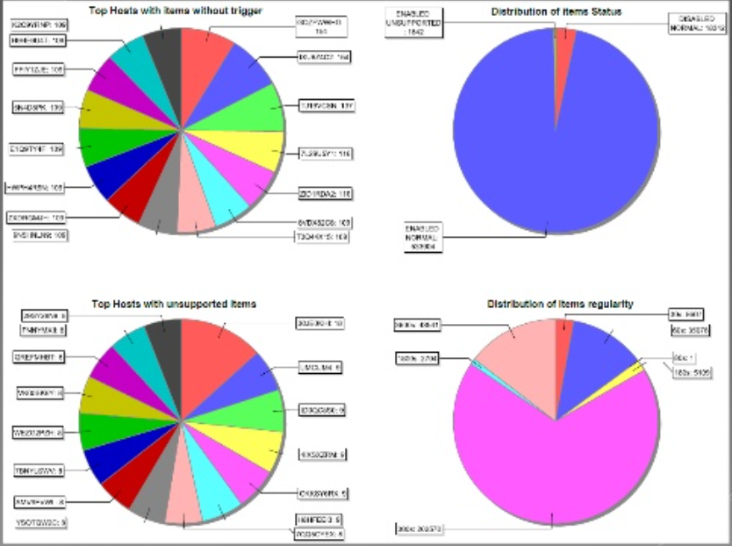
Figure 9: Host Distribution and CPU & Memory Yearly Trend Reports Examples

Appendix-D: Dashboard examples

Device Summary Dashboard Example

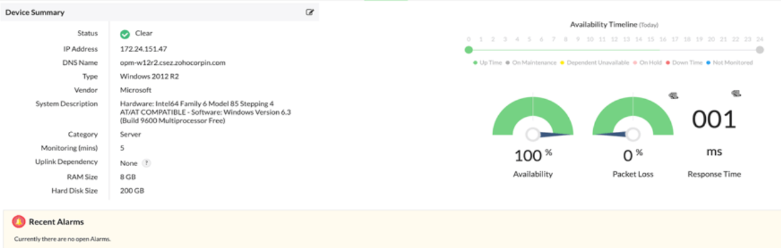

Figure 10: Device Summary Report Example

VM Information Dashboard Example
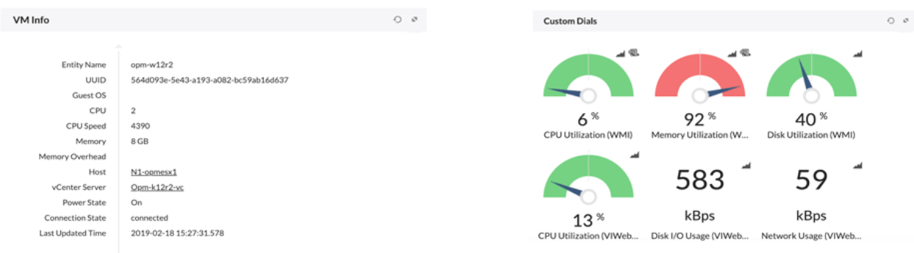

Figure 11: VM Information Report Example

Network Dashboard Example
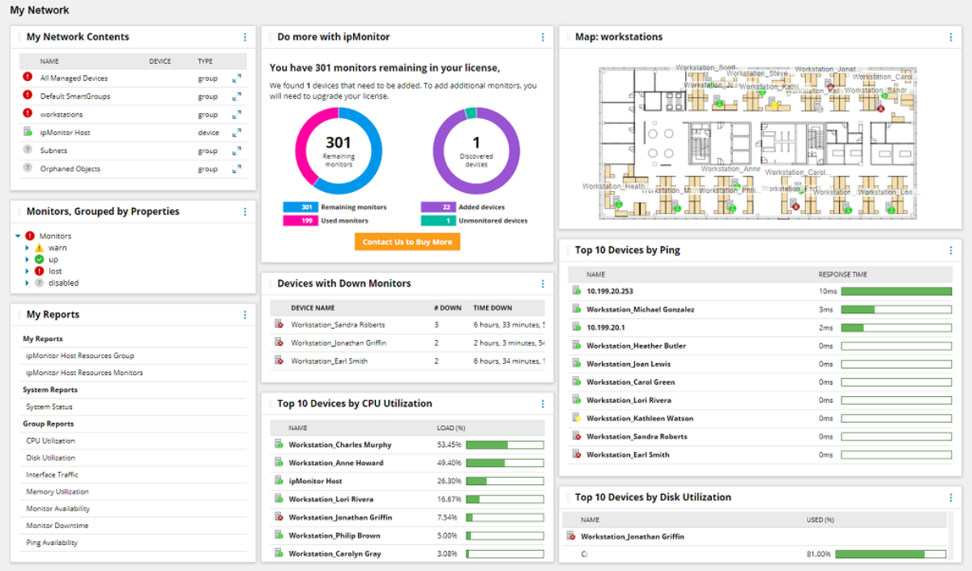
Figure 12: Network Dashboard and Network Report Example

Performance Dashboard Example
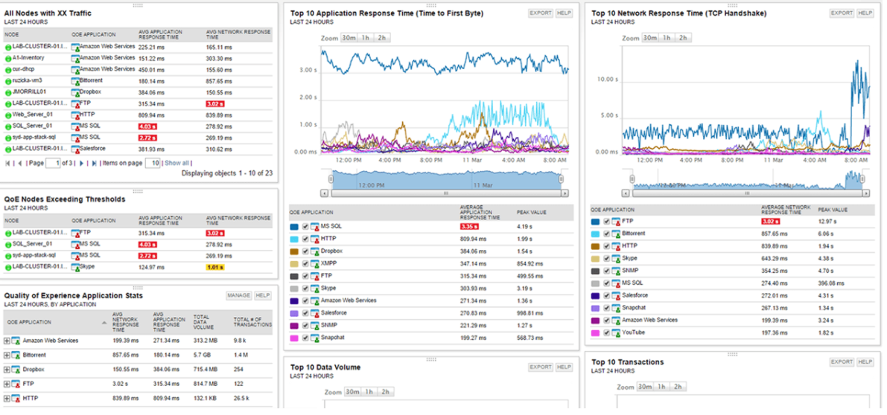
Figure 13: Performance Report Example

Host Service Status Dashboard Example
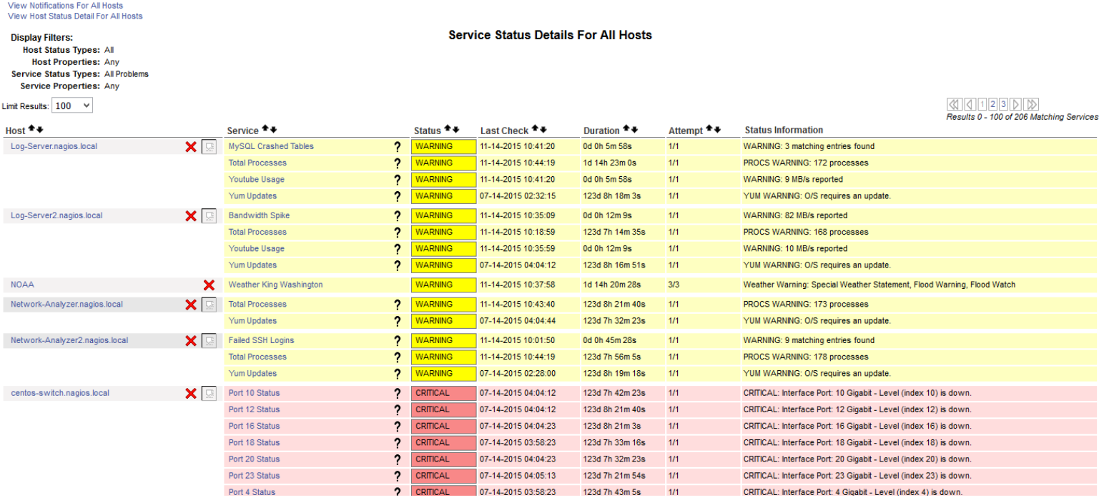

Figure 14: Host Service Status Report Example

Complete Dashboard Example
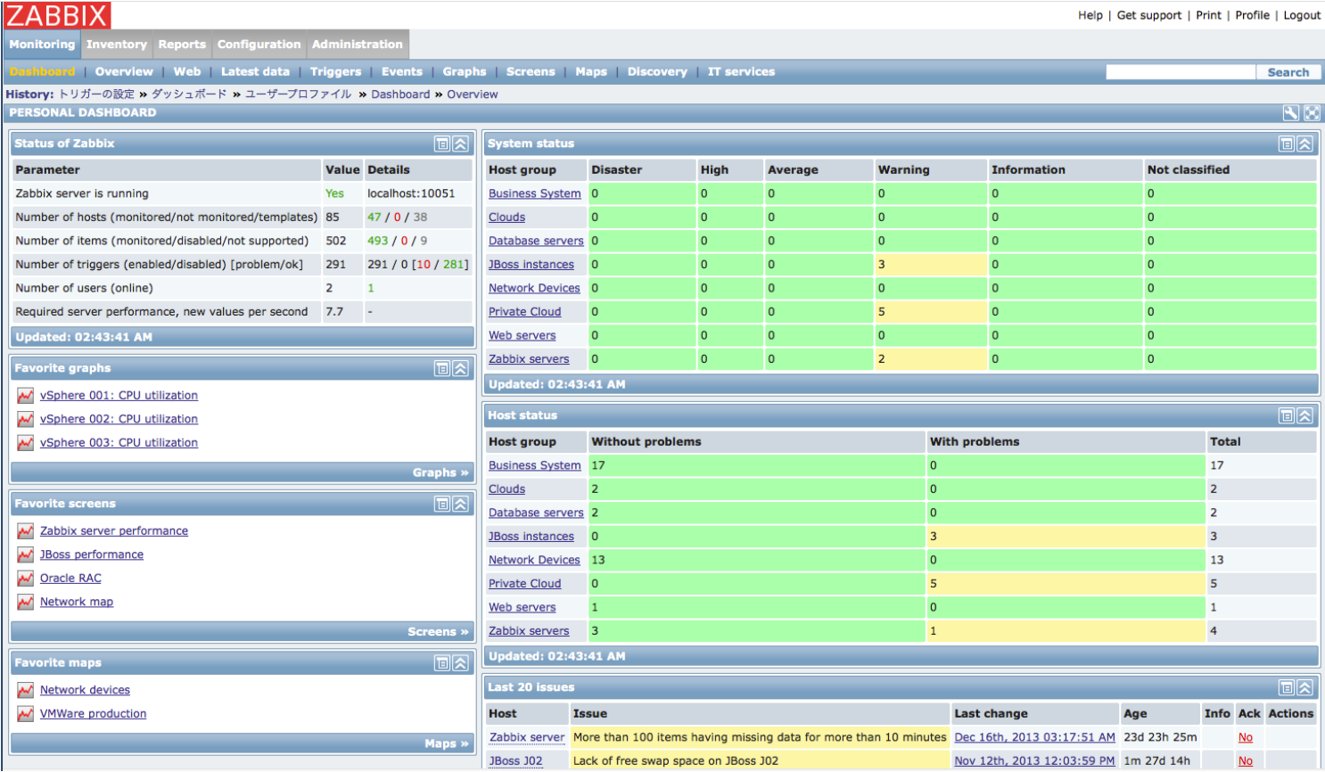

Figure 15: Complete Dashboard Example

